H-9801.1
_______________________________________________

HOUSE BILL 3801
_______________________________________________

State of Washington 67th Legislature 2022 Regular Session

By Representative Barkis

AN ACT Relating to test of image insertion; and amending RCW 1.20.080.

BE IT ENACTED BY THE LEGISLATURE OF THE STATE OF WASHINGTON:
Sec. RCW 1.20.080 and 1967 ex.s. c 65 s 1 are each amended to read as follows:
The seal of the state of Washington shall be, a seal encircled with the words: "The Seal of the State of Washington," with the vignette of General George Washington as the central figure, and beneath the vignette the figures "1889" and shall be composed as appears in the illustration below:
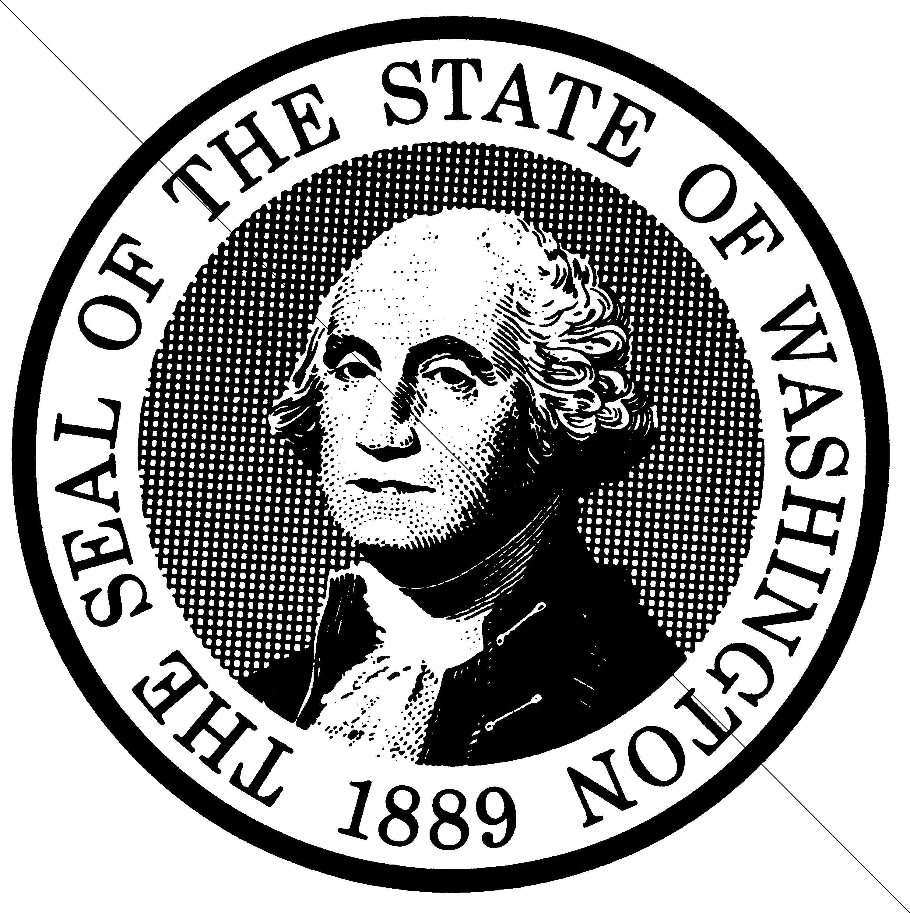

--- END ---

